Remote Consultations in Mental Health Project: SLaM Case Study – Barbara Arroyo
Barbara Arroyo, Interim Chief Clinical Information Officer at South London, and Maudsley NHS Foundation Trust (SLaM) gave an overview of how the Community Mental Health team in Southwark, prompting recovery in people living with serious mental illness; particularly with primary and secondary diagnosis of psychosis, has adapted to virtual working within the team and with their service users durin g the Covid19 pandemic.
For context, Barbara’s team consists of 14 members and includes administrators, receptionists, a psychologist, occupational therapist, team manager, nurses, social care workers, care coordinators and psychiatrists. The community mental health team provides services and support to 250 service users across Southwark.
Coordinating Patient’s Care in a Virtual Setting:
The Care Coordinators working in the community mental health team at SLaM coordinates the care of each patient. This isn’t just medication. The care coordinators will know each person’s needs. They will work with the individual service user and wider members involved in the person’s care, for example carers, to understand their preferences for care and treatment.
When we entered the pandemic, Barbara’s team realised they couldn’t carry on working utilising the same care coordination model. Instead, the team had to work in a task orientated way utilising Microsoft Teams. The team held basic understanding of Microsoft Teams from running Virtual Clinics prior to Covid19, however nobody was an expert in this area and so a lot of peer support, coaching, tutorials and 1:1s were conducted to ensure the team felt confident in utilising its functions. As Barbara stated, “We helped each other. We did the coaching and the tutorials as we know it is something to stay and that will be sustainable. If the staff is digitally confident and competent, then they will be able to share knowledge and learning with patients”. As well as using the video functionality, the team used document sharing.
Barbara highlights how they utilised Microsoft Teams Document Sharing to perform their day-to-day roles and support patient outcomes.

We created an Excel spreadsheet with all the patients and their interventions on our patch. We downloaded Microsoft Teams to our phones so we could have easy access to communicate if somebody was on annual leave or was sick and we could view the database remotely on the go if need be. We started having huddles in the morning at 10am and again at 4pm. We would go through the task list twice a day. In the morning, we would see who the patient was and then we could go to the task and see what needed to be done. There was a clear allocation of people in the team who would need to do the essential in person work and plan urgent activities, and people at home that could do the follow up phone calls. It allowed us to stay connected to everybody, and on the 4pm meeting we would check what had happened in the day. On the spreadsheet, if we hadn’t contacted a patient, it would roll over into the next day. If they had been contacted then it would show green and we know we can then make contact in 2 weeks’ time, 1 week or 4 weeks’ time etc. As a staff member, if you weren’t there, there was no expectation that you needed to catch up regarding handover as it would all be listed clearly on the Microsoft Teams Document”.

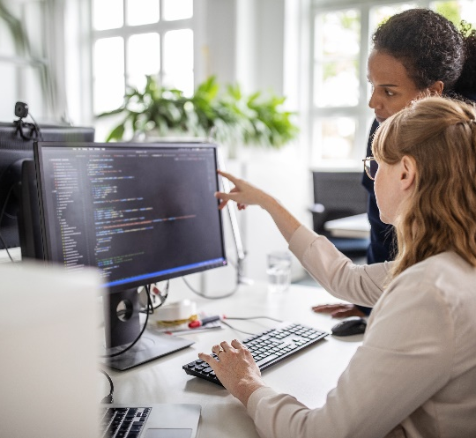

Allowing Patients to become digitally aware:
The Community Mental Health Team at SLaM, based in Southwark, did not exclude any patient. They utilised a hybrid model, offering telephone, video and face to face consultations. Choosing which method of consultation is best for the patient depended upon the clinical intervention and the preferences of staff and patients.
“The tree of decision making starts with ‘What is the clinical intervention?’ and then ‘What are the options?’, ‘What is the preference from everybody?’. What we found over time is that the confidence built in terms of moving towards a more hybrid approach. Staff who at the beginning were not so keen, now utilise video and telephone consultations. Patients as well. I think the collective confidence and competence has increased”.

If a patient were to be seen face to face for their initial appointment due to their need, lack of digital accessibility or knowledge, the patient would come into clinic and enter a room with a clinician. On the screen would be the MDT. The patient is not only visualising how the team are there to support them, they are also witnessing how easy and accessible digital platforms can be.
“The patient would attend their appointment with me, and I would facilitate it through video. The care coordinator, the house officer, the carers and everybody else would come in the video. The patient did not need to have any prior digital knowledge or access. That is how we got around the digital exclusion. We would facilitate the digital platform for them. Instead of having a room of 5 people (patient, doctor, care coordinator etc.), or nobody coming, we facilitated their appointment through video. It is the first time that patients will see the video and see that there is 6 people, for example, supporting them. If patients did not feel comfortable with the video functionality, we would switch the cameras off. A lot of patients saw how we use the technology and thought it was brilliant and was very containing”.

“Once the meeting had finished, I would spend time with the patient in sharing the learning with them around digital access. I would encourage the patient to bring to their appointment an iPad, a tablet device or a mobile, if they had one. I would support them to log into NHS Wi-Fi. I would then spend 10 minutes of our meeting helping them to log into Teams to see how it works. It is about the sustainability of these things. Some people think they don’t have time for this, but I say it is an investment. I would then say, ‘Let’s catch up again next week using this technology’. Once people got it, they loved it as it meant it fitted around their needs. They didn’t have to commute to appointments. Care Coordinators did not need to complete home visits, putting themselves and patients at risk during the pandemic. It was win, win. For some people it meant that the mother could be there, or their son could be there”.

Not only did SLaM’s Community Mental Health Team in Southwark encourage patients to utilise digital platforms for their appointments, but for self-management of their conditions, including access to Personalised Health Records, SLaM Recovery College and informative self-management video’s.

“We also have a Personalised Health Record called Beth. It was the start of the conversation because we said, ‘If you like this (remote consultations), we have a Personalised Health Record that you can access. If you sign on to it, you will see your appointment already in the calendar. We also have secure messaging and if you’d like, we can also share your care plan with you’”.

“…they also signed with SLAM Recovery College. Once you get into that world, it is a different landscape as suddenly you have SLAM Recovery College, Personalised Health Record, availability to do video calls, carers forums etc. It opens a different line of support”.

“There are very good physical health videos by NHSX. You would look for diabetes and you can see foot care, eye care, what a care plan looks like etc. This would allow people to be encouraged to watch things in their own time or encourage them to find out more, but also bring care closer to patients.”

Not only does encouraging patients to utilise digital interventions for their consultations and self-management provide them with new opportunities, it allows them to feel more empowered and feel closer to their clinicians and support network than before.
“If there is somebody, we just need to check that they are okay, I can arrange something quickly. I can arrange it the week before. When it was by letter, people had to come in and you need to give more notice. If the patient wants to reschedule or cancel, it is a lot quicker for them and easier”.

“People feel more empowered. They feel that we are taking them into consideration and valuing their time. As a doctor, it felt everything used to fit around my clinics. Now, it feels a lot more even and I think it promotes more engagement”.

Barbara states how patient motivation to utilise digital interventions is essential.
“It is not a case that they don’t know how to do it on their own. It is about motivation. I think motivation is just as big as barrier as the actual basic skills and affordability of devices. When you collaborate with patients, you are saying ‘this is going to be useful as we are can communicate like this’. You are engaging with them. There is something about partnership”

The Future of Remote Working:
Barbara expressed how beneficial utilising digital platforms can be in joining up various organisations across the NHS and beyond. If clinicians can link up and understand the offer for their patients, they can better inform them on what can support them to manage their conditions.
“We are going through a community transformation, so we are going to have better links with GPs, social care, acute and community at large e.g., vocational organisations etc. My idea is to use this digital technology to link up with them. If I can speak to colleagues in GP practices, Adult Social Care service and aligned voluntary care sector in an easy way utilising digital, then I can make that transition to better inform care for patients. Our goal is to help people to become more autonomous and be as independent as they can be. We want them to gain as much control over their lives again. That is what serious mental illness does. It limits you; it takes things away from you…”.

